**Assignment 2**

Zichen Jiang - jiangz2 - 1320889

Danish Khan - khand5 - 1217176

Kelvin Lin - linkk4 - 1401464

Hasan Siddiqui - siddih8 – 1450148

Portions of this report reflective of Assignment 1 were created by:

Kelvin Lin – linkk4 – 1401464

Kerala Brendon – brendokh – 1424625

Jeremy Klotz – klotzj – 1426853

Course Code:

SFWR ENG 2AA4/COMP SCI 2ME3

Due Date:

March 23rd, 2016

By virtue of submitting this document we electronically sign and date that the work being submitted is our own individual work.

# Table of Contents

Table of Contents 1

1 Introduction and Architecture 3

2 Modular Decomposition and Hierarchy 3

3 Module Guide 5

3.1 MIS 5

3.1.1 CLASS: CIRCLE 5

3.1.2 CLASS: DEBUGCONTROLLER 5

3.1.3 CLASS: ERRORDIALOG 6

3.1.5 CLASS: MENUVIEW 6

3.1.6 CLASS: PLAYER 7

3.1.7 CLASS: POINT 7

3.1.8 CLASS: RECTANGLE 8

3.1.9 CLASS: SCREEN 9

3.1.10 CLASS: BOARD 9

3.1.11 CLASS: BOARDCONTROLLER 10

3.1.12 CLASS: BOARDVIEW 10

3.1.13 CLASS: GAME 11

3.2 MID 12

3.2.1 CLASS: CIRCLE 12

3.2.2 CLASS: DEBUGCONTROLLER 13

3.2.3 CLASS: ERRORDIALOG 15

3.2.4 CLASS: MENUCONTROLLER 16

3.2.5 CLASS: MENUVIEW 17

3.2.6 CLASS: PLAYER 19

3.2.7 CLASS: POINT 19

3.2.8 CLASS: RECTANGLE 20

3.2.9 CLASS: SCREEN 21

3.2.10 CLASS: BOARD 22

3.2.11 CLASS: BOARDCONTROLLER 25

3.2.12 CLASS: BOARDVIEW 29

3.2.13 CLASS: GAME 32

4 Trace to Requirements 33

5 Uses Relationship 35

6. Anticipated Changes & Discussion 36

6.1 There Can Be More States than the Defined States 36

6.2 The Player Can Play Against the Computer 36

6.3 The application must efficiently store and search for a piece’s next path 36

6.4 The Game Can Be Expanded to N Men’s Morris 36

6.5 Additional Components Can Be Added to the Views 37

6.6 The Users Can Make an Infinite Number of Moves 37

6.7 The Platform Will Change Over Time 37

6.8 The Resolution of Computer Screens Will Change Over Time 37

7 Test Plan/Design 38

7.1 Testing for Assignment 1 38

7.1.1 Requirement 1 38

7.1.2 Requirement 2 38

7.1.3 Requirement 3 38

7.1.4 Requirement 4 39

7.1.5 Requirement 5 39

7.1.6 Requirement 6 40

7.1.7 Requirement 7 40

7.1.8 Requirement 8 41

7.1.9 Requirement 9 41

7.2 Testing for Assignment 2 42

7.2.1 Requirement 1 42

7.2.2 Requirement 2 43

7.2.3 Requirement 3 44

7.2.4 Requirement 4 44

7.2.4 Requirement 5 45

7.2.6 Requirement 6 46

7.2.7 Requirement 7 48

7.2.8 Requirement 8 48

8 Conclusion 51

9 Appendix 53

9.1 Change log 53

9.2 List of Tables 54

9.3 List of Figures 54

# 1 Introduction and Architecture

This report will document the design and the decisions made in Assignment 2 for Sfwr Eng 2AA4/Comp Sci 2ME3. The report will begin with an overview of the architecture and modules used in the application. Then the decomposition hierarchy will be examined in order to highlight its dependencies and to prepare a premise for a discussion on anticipated changes and other traditional software engineering practices. This report will end with a test plan, which will show that the application does fulfil the requirements up to the level specified in the document.

The architecture chosen for this application is the Model-View-Controller (MVC) architecture. The MVC architecture was chosen because it accentuates the principle of separation of concerns. The MVC architecture consists of three main components: the model, the controller, and the view. With the MVC architecture, the model represents data related to the logic the user works with, the view represents the user interface, and the controller facilitates the interaction between the model and the view. We believe that by using this architecture, different aspects of the program could be separated in order to facilitate testing and implementing future changes.

Note that this report encompasses the design decisions for both assignment 1 and assignment 2. This is deliberately done in order to demonstrate growth, how design decisions from the first assignment impacted the second assignment, and how the group handled poor design from the first assignment.

# 2 Modular Decomposition and Hierarchy

The application was designed using a top down approach. The top down approach was used in order to facilitate modular design and to accentuate separation of concerns. By using top down design, the application can be decomposed into modules, which are responsible for a single work assignment. Knowing the individual modules will allow programmers to program using the bottom-up approach, which would allow for early testing, and quick implementation of the application.

The figure below shows the modular decomposition hierarchy for the application. Arrows point towards increasing modularity (from less modular to more modular):

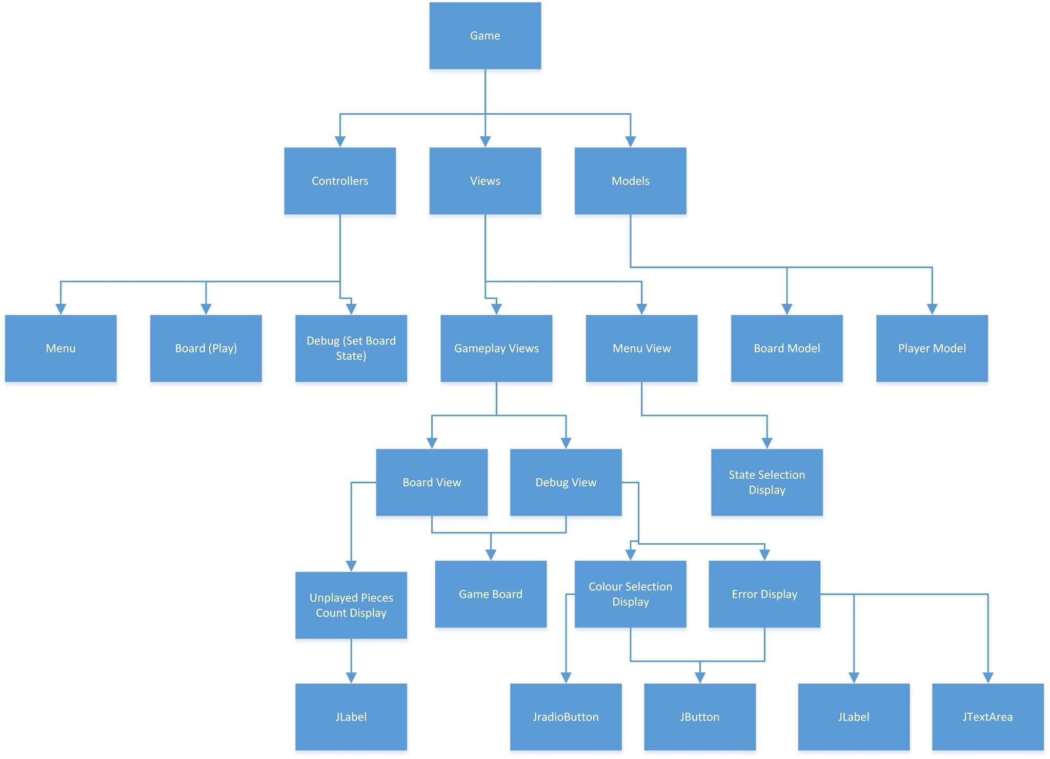

##### Figure 1: The Decomposition Hierarchy

From the diagram above, it is clear that the game is decomposed into controllers, models, and views. This reflects our design decision to implement Six Men’s Morris using the MVC architecture. The controller is then decomposed into the Menu, Board, and Debug modules. The menu is used to fulfill the requirement of having multiple ways to start a game (i.e. by starting a new game, by loading a saved state, and by setting a preset state). The board represents the requirement that the user has to play the game. The debug state represents the requirement that the user should be able to place pieces on the board in order to set the initial state. The view is decomposed into the gameplay views, and the menu view. The menu view fulfills the requirement that the user must be able to see the menu when they are in the menu state. The gameplay view is further decomposed into the board view and the debug view which facilitates displaying the user interface to the user. Finally, the models are decomposed into the two main components of the game: Board and Player. The board facilitates all of the game operations such as checking win conditions, draw conditions, and representing the state of the board. The player model fulfills the requirement of allowing users to place pieces onto the board.

# 3 Module Guide

## 3.1 MIS

### 3.1.1 CLASS: CIRCLE

Defines a mathematical representation of a circle using its center point and radius. Contains access programs to field variables, and to detect user input.

***INTERFACE***

***USES***

Point

***TYPE***

None

***ACCESS PROGRAMS***

**Circle(Point center, double radius)**

Constructor method required to create object of type Circle with a radius and center point.

**getIntDiameter(): int**

Returns the diameter d of the circle as an integer, $d=2r$

**getIntPointX(): int**

Returns the x-coordinate of the center point as an integer.

**getIntPointY(): int**

Returns the y-coordinate of the center point as an integer.

**getIntRadius(): int**

Returns the radius of the circle as an integer.

**isMouseOver(Point mouse): boolean**

Returns TRUE if mouse is pointing over the circle, otherwise returns FALSE

### 3.1.2 CLASS: DEBUGCONTROLLER

Creates the window and all labels or buttons needed to access and update the view which in turn will change values in the model.

***INTERFACE***

***USES***

BoardView

DebugController

***TYPE***

None

***ACCESS PROGRAMS***

**DebugController(int N)**

Construct the state based on the number of layers.

### 3.1.3 CLASS: ERRORDIALOG

Defines a dialog box to display error messages to the user. Contains an access program to respond to the user’s input.

***INTERFACE***

***USES***

JDialog, ActionListener

***TYPE***

None

***ACCESS PROGRAMS***

**ErrorDialog(JFrame parent, String title, String message)**

Initializes a dialog to display any errors found during the execution of the application

**actionPerformed(ActionEvent e)**

Responds to the user’s input

**3.1.4 CLASS: MENUCONTROLLER**

Defines a controller to mediate the views and models used in the menu.

***INTERFACE***

***USES***

MenuView, JFrame

***TYPE***

None

***ACCESS PROGRAMS***

**MenuController()**

Instantiates the view and any field variables used in the module.

**run(): void**

Runs any operations associated with the controller.

**getJFrame(): JFrame**

Returns the JFrame.

### 3.1.5 CLASS: MENUVIEW

Defines a view for the menu screen.

***INTERFACE***

***USES***

Screen

***TYPE***

None

***ACCESS PROGRAMS***

**MenuView(int N)**

Instantiates the objects on the screen and any field variables used in the module.

**getState():int**

Returns the state of the application.

**updateScreen(): void**

Updates the screen.

**paintComponent(Graphics g): void**

Draws the required components onto the screen.

### 3.1.6 CLASS: PLAYER

Each player is determined by two integers. An integer that represents their color , and the number of pieces they have left to place.

***INTERFACE***

***USES***

None

***TYPE***

None

***ACCESS PROGRAMS***

**Player(int color, int numberOfUnplayedPieces)**

Initializes field variables

**getColor():int**

Returns the color of the player.

**getNumberOfUnplayedPieces():int**

Returns the number of pieces the player has yet to place.

**placePiece(): void**

Models the action of the user playing a piece on the board.

### 3.1.7 CLASS: POINT

Defines a mathematical representation of a circle using its x-coordinate and its y-coordinate.

***INTERFACE***

***USES***

None

***TYPE***

None

***ACCESS PROGRAMS***

**Point(double x, double y)**

Initializes the field variables

**getX(): double**

Returns the x-coordinate.

**getY(): double**

Returns the y-coordinate.

**getIntX(): int**

Returns the x-coordinate as an integer.

**getIntY(): int**

Returns the y-coordinate as an integer.

**getDistance(Point that): double**

Return the distance between two point objects, 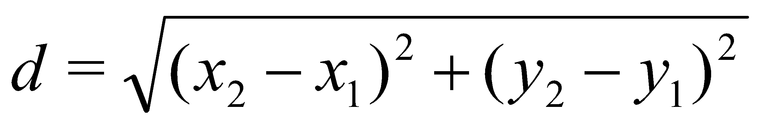

### 3.1.8 CLASS: RECTANGLE

Defines a mathematical representation of a rectangle defined by the top left, top right, and bottom left corners.

***INTERFACE***

***USES***

Point

***TYPE***

None

***ACCESS PROGRAMS***

**Rectangle(Point topLeft, Point topRight, Point bottomRight)**

Initializes the field variables

**getTopLeft(): Point**

Returns the top left point of the rectangle.

**getTopRight(): Point**

Returns the top right point of the rectangle.

**getBottomRight(): Point**

Returns the bottom right point of the rectangle.

**getIntWidth(): int**

Returns the width of the rectangle, 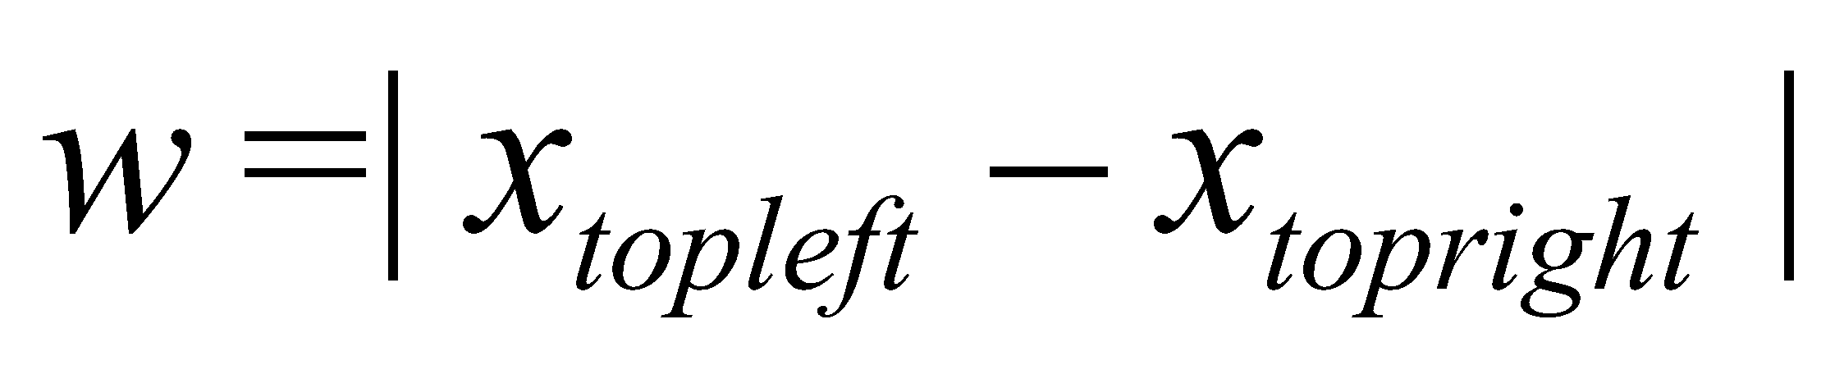

**getIntHeight():int**

Return the height of the rectangle, 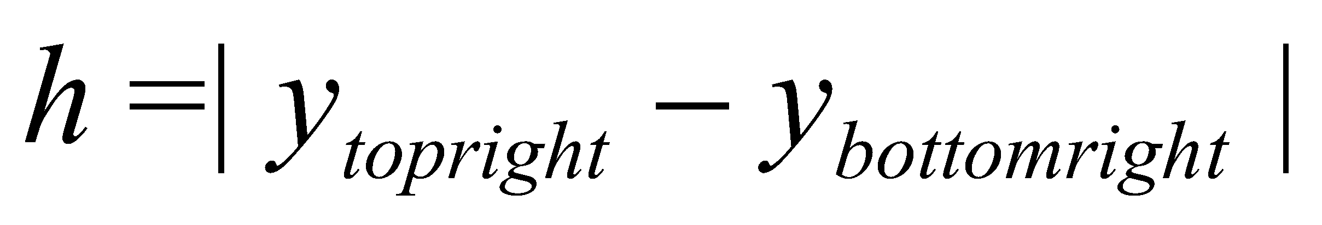

**getTopLeftIntX(): int**

Return the x-coordinate of the top left corner as an integer.

**getTopLeftIntY(): int**

Return the y-coordinate of the top left corner as an integer.

**getBottomLeft(): Point**

Return the bottom left point, defined by 

### 3.1.9 CLASS: SCREEN

Declares a function that will be used in classes that extend from it. In this assignment, that would be the classes menuView, and boardView. It is a template for the views.

***INTERFACE***

***USES***

None

***VARIABLES***

None

***ACCESS PROGRAMS***

**updateScreen():void**

Updates the screen

### 3.1.10 CLASS: BOARD

This is an abstract representation of the game board. It keeps the state of each piece in a 1 dimensional array in order to reduce run time and space.

***INTERFACE***

***USES***

None

***TYPE***

None

***ACCESS PROGRAMS***

**Board(int N)**

Constructs an array representation of the board.

**Board(int N, int[] pieces)**

Constructs an array representation of the board given a preset state.

**setPieces(int[] pieces): void**

Initializes the pieces array.

**getN(): int**

Returns the number of squares on the board.

**setPieceState(int number, int state): void**

Set the state of a piece on the board

**getBoardState: int[]**

Return the current state of the board

**getPieceState(int number): int**

Return the current state of the piece (black, red or blue)

**millExists(int i): int[]**

Return the positions of the pieces that forms a mill.

Returns [-1,-1,-1] if no mill found.

**onlyMillsLeft(int color): boolean**

Return true if there is only one mill left, and false otherwise.

**boardIsEqual(int[] board1, int[] board2): boolean**

This method is used to check if the given two boards are the same.

### 3.1.11 CLASS: BOARDCONTROLLER

This is a controller for the board class. It acts as an intermediary between the Board model (Board.java), and the Board view (BoardView.java).

***INTERFACE***

***USES***

BoardView

Player

***TYPE***

None

***ACCESS PROGRAMS***

**BoardController(int N)**

Create a new board controller with an N-men’s Morris board.

**BoardController(int N, int[] boardState)**

Create a new board controller with an N-men’s Morris board and a specified

board state.

**BoardController(int N, int[] boardState, int turn, int state)**

Create a new board controller with an N-men’s Morris board, a specified

board state and a specified player’s turn.

### 3.1.12 CLASS: BOARDVIEW

This class displays the board to the user.

***INTERFACE***

***USES***

Screen

Board

Circle[]

***TYPE***

None

***ACCESS PROGRAMS***

**BoardView(int N)**

Constructs the screen needed to play the game, and adds all EventListeners needed to obtain input from the user.

**BoardView(int N, int[] boardState)**

Construct the screen needed to play the game given a certain state, and adds all EventListeners needed to obtain input from the user.

**pieceNotTaken(int number): boolean**

Return a boolean value that determines if a piece is already placed in a certain location.

**getBoardStates(): int[]**

Return the state of the board (player Red or player Blue).

**setBoardState(int number, int state): void**

Set the state of the board.

**getBoardState(int number): int**

Return the state of the board.

**getCircles(): Circle[]**

Return the array of all circles in the board

**setState(int[] states): void**

Set the states of the game.

**updateScreen(): void**

Updates the screen.

**paintComponent(Graphics g): void**

Draw board.

**millsExist(int i): boolean**

Returns whether a mill including the piece at index i exists.

**existsOnlyMills(int colour): boolean**

Returns whether there only exists mills on the board with the specified colour.

**checkWinner(): int**

Returns whether or not there is a winner in the game: 0 if there is no winner, 1 if the winner is blue, 2 if the winner is red.

**getRepeats(): int**

Returns the number of repetitions.

### 3.1.13 CLASS: GAME

***INTERFACE***

***USES***

None

***TYPE***

None

***ACCESS PROGRAMS***

**main(String[] args)**

The Main method that creates an object of type controller and sets the window to be visible. Essentially runs the entire program.

## 

## 3.2 MID

### 3.2.1 CLASS: CIRCLE

Defines a mathematical representation of a circle using its center point and radius. Contains access programs to field variables, and to detect user input.

***IMPLEMENTATION***

***USES***

Point

***VARIABLES***

**center: Point**

The center point of the circle.

This variable is kept private to reduce coupling between modules, and implement information hiding. It is maintained by getIntPointX(), getIntPointY(), and isMouseOver().

**radius: double**

The radius of the circle.

This variable is kept private to reduce coupling between modules, and implement information hiding. It is maintained by getIntDiameter(), getIntRadius(), and isMouseOver().

***ACCESS PROGRAMS***

**Circle(Point center, double radius)**

Constructor method required to create object of type Circle with a radius and center point.

**getIntDiameter(): int**

Returns the diameter d of the circle as an integer,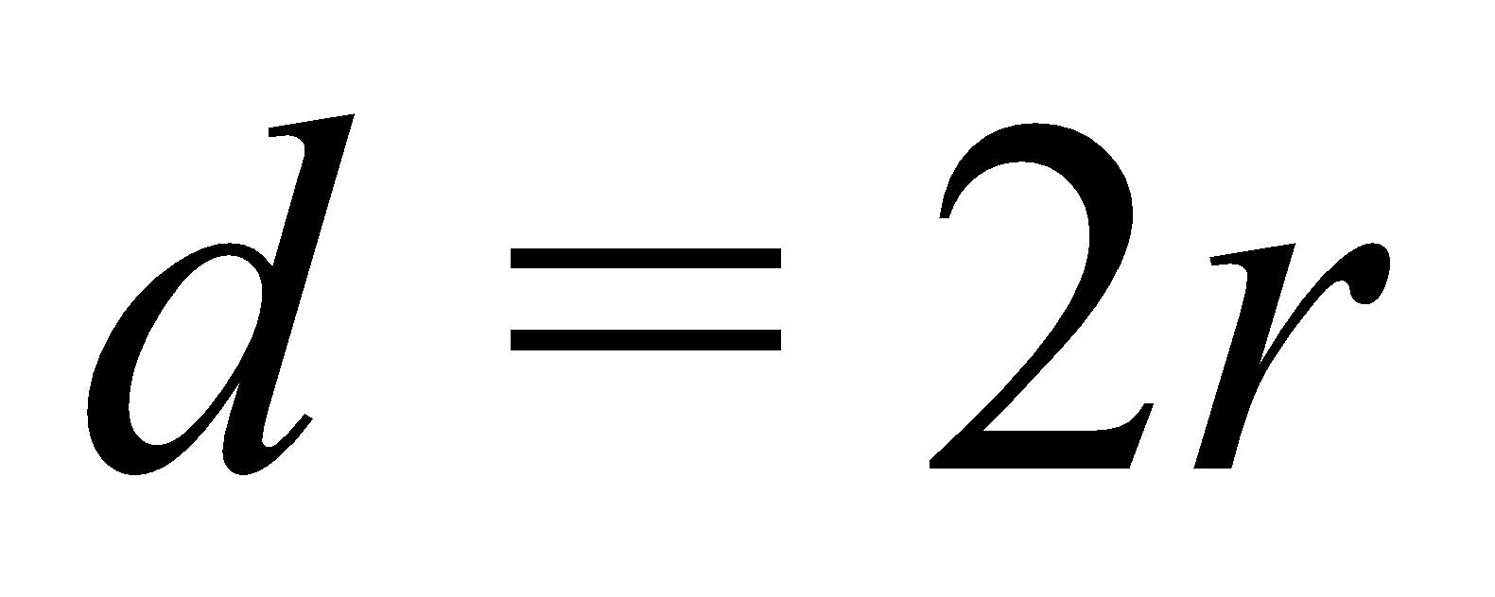.

**getIntPointX(): int**

Return the X - coordinate of the center point

**getIntPointY(): int**

Return the Y - coordinate of the center point

**getIntRadius(): int**

Return the radius of the circle as an integer.

**isMouseOver(Point mouse): boolean**

Returns TRUE if mouse is pointing over the circle, otherwise returns FALSE

Return x > center.getIntX() - radius && x < center.getIntX() + radius && y > center.getIntY() - radius && y < center.getIntY() + radius;

### 3.2.2 CLASS: DEBUGCONTROLLER

Creates the window and all labels or buttons needed to access and update the view which in turn will change values in the model.

***IMPLEMENTATION***

***USES***

JFrame

BoardView

JRadioButton

ButtonGroup

JButton

DebugController

***VARIABLES***

**jFrame: JFrame**

A variable that represents the JFrame object.

This variable is kept private to reduce coupling between modules, and implement information hiding. It is maintained by the constructor.

**boardView: BoardView**

A variable that represents the BoardView object.

This variable is kept private to reduce coupling between modules, and implement information hiding. It is maintained by the constructor.

**NUMBER\_OF\_PIECES = 6: int**

Instantiate number of pieces per player, if this was 9 men’s morris, it would change to 9 etc.

This variable is final.

**BLUE\_STATE = 1: int**

Blue state is index 1.

This variable is final.

**RED\_STATE = 2: int**

Red state is index 2

This variable is final.

**FONT\_SIZE = 25: int**

Set default font size

This variable is final.

**DEFAULT\_SCREEN\_WIDTH = 500: int**

Set default screen width

This variable is final.

**DEFAULT\_SCREEN\_HEIGHT = 500: int**

Set default screen height

This variable is final.

**blue, red, black: JRadioButton**

Series of JRadio buttons.

This variable is kept private to reduce coupling between modules, and implement information hiding. It is maintained by the constructor and MouseClickEventHandler.mousePressed().

**buttonGroup: ButtonGroup**

Put buttons in a group so only one can be pressed at a time

This variable is kept private to reduce coupling between modules, and implement information hiding. It is maintained by the constructor.

**playGame: JButton**

Will change the application state to regular gameplay

This variable is kept private to reduce coupling between modules, and implement information hiding. It is maintained by the constructor and resizeText();

**N: int**

Number of layers/ rectangles

This variable is kept private to reduce coupling between modules, and implement information hiding. It is maintained by the constructor and playGameMouseClicked();

***ACCESS PROGRAMS***

**DebugController(int N)**

Construct the state based on the number of layers.

*Instantiate debugging window*

*Font size scalable to window,*

*frame width \* FONT\_SIZE / DEFAULT\_SCREEN\_WIDTH*

*3 JRadio buttons*

**playGameMouseClicked(MouseEvent e): void**

This method performs when the play game button is clicked.

*if boardIsLegal is true*

*Set up boardController*

**boardIsLegal(): boolean**

Return a boolean value that determines if the board is of legal creation by the user.

*if error*

*new error dialog*

*return false*

**checkNumbers(): String**

This method checks the debugging board to see how many pieces of each colour are present, if the number is illegal, returns error message.

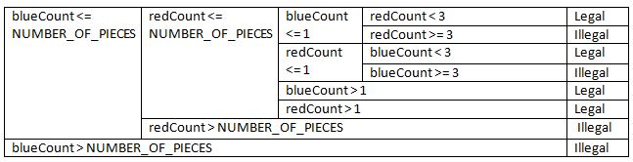

###### Table 1: checkNumbers() tabular expression

**resizeText(): void**

Adjusts the font for all text involved, making it able to be resized based on the window size. Sets the font of blue, red, black and playGame.

Equation for font: 

**updateView(): void**

Updates the view if and where it is needed by using invalidate and repaint.

**MouseClickEventHandler *implements* MouseListener**

**mouseClicked(MouseEvent e): void**

Called if the mouse is clicked on a board node, and one of the JRadio buttons (red, blue or black) is selected.

*Instantiate points*

*for i in range of length circles*

*if blue is selected*

*make circle at i blue*

*else if red is selected*

*make circle at i red*

*else if black is Selected*

*make circle at i black*

*update view*

### 3.2.3 CLASS: ERRORDIALOG

Defines a dialog box to display error messages to the user. Contains an access program to respond to the user’s input.

***IMPLEMENTATION***

***USES***

JDialog

Action Listener

BorderLayout

***VARIABLES***

**FONT\_SIZE = 0: int**

The default font size.

This variable is final.

***ACCESS PROGRAMS***

**ErrorDialog(JFrame parent, String title, String message)**

Catches errors that may occur in the application while the user is running it.

*Set the font*

*Button when clicked analyses board*

*Instantiate errorMessages*

**actionPerformed(ActionEvent e)**

If an action can be performed, then there is no need to show the error message, so this will set the visible value to false.

### 3.2.4 CLASS: MENUCONTROLLER

Defines a controller to mediate the views and models used in the menu.

***IMPLEMENTATION***

***USES***

JFrame

MenuView

***VARIABLES***

**jFrame: JFrame**

This represents the jFrame to be displayed to the user.

This variable is kept private to reduce coupling between modules, and implement information hiding. It is maintained by run() and getJFrame().

**view: MenuView**

This represents the menuView to be displayed to the user.

This variable is kept private to reduce coupling between modules, and implement information hiding. It is maintained by run().

**nextState: int**

This returns the next state to the user.

This represents the jFrame to be displayed to the user. This variable is kept private to reduce coupling between modules, and implement information hiding. It is maintained by getNextState().

***ACCESS PROGRAMS***

**MenuController()**

Method to construct the output that the controller will handle everything inside of it. It instantiates views.

**run(): void**

Update the screen whenever the components need to be resized.

**getJFrame(): JFrame**

Return the window object.

**getNextState(): int**

Return the next state of the application.

Menu_Table.JPG

###### Table 2: getNextState() tabular expression

### 3.2.5 CLASS: MENUVIEW

Defines a view for the menu screen. Instantiates what thing must be communicated to the user when called by the controller.

***IMPLEMENTATION***

***USES***

Screen

JLabel

JButton

***VARIABLES***

**title: JLabel**

The label title. This represents the jFrame to be displayed to the user.

This variable is kept private to reduce coupling between modules, and implement information hiding. It is maintained by draw(), updateScreen(), and paintComponent().

**playGame: JButton**

User will click to go directly to play state.

This variable is kept private to reduce coupling between modules, and implement information hiding. It is maintained by playGameMouseClicked(), draw(), updateScreen(), and paintComponent().

**debug: JButton**

User will click to go to debugging and then to play state.

This variable is kept private to reduce coupling between modules, and implement information hiding. It is maintained by MenuView(), debugMouseClicked(), draw(), updateScreen(), and paintComponent().

**state: int**

Keeps track of the state the game is in.

This variable is kept private to reduce coupling between modules, and implement information hiding. It is maintained by MenuView(), and getState().

**boardState: int[]**

Keeps track of the state of the saved board.

This variable is kept private to reduce coupling between modules, and implement information hiding. It is maintained by loadGameMouseClicked().

**turn: int**

Keeps track of the turn of the saved board.

This variable is kept private to reduce coupling between modules, and implement information hiding. It is maintained by loadGameMouseClicked().

**gameState: int**

Keeps track of the game state of the saved board.

This variable is kept private to reduce coupling between modules, and implement information hiding. It is maintained by loadGameMouseClicked().

**removePiece: boolean**

Keeps track of whether the player is eligible to mill.

This variable is kept private to reduce coupling between modules, and implement information hiding. It is maintained by loadGameMouseClicked().

**defaultFontSize: int**

Sets the default font size.

This variable is kept private to reduce coupling between modules, and implement information hiding. It is maintained by draw(), updateScreen(), paintComponent().

**defaultScreenWidth: int**

Sets the default screen width.

This variable is kept private to reduce coupling between modules, and implement information hiding. It is maintained by draw(), updateScreen(), paintComponent().

**N: int**

The number of layers.

This variable is kept private to reduce coupling between modules, and implement information hiding. It is maintained by MenuView(), draw(), updateScreen(), and paintComponent().

***ACCESS PROGRAMS***

**MenuView(int N)**

Constructor method.

*Instantiate play game and debug buttons*

*mouseClicked method*

*Instantiate Box*

**getState():int**

Return the state of the application

**playGameMouseClicked(MouseEvent e): void**

If the mouse was clicked on the play game button

*Set BoardController to visible*

**debugMouseClicked(MouseEvent e): void**

If the mouse was clicked on the debug button

*Set DebugController to visible*

**draw(Graphics g): void**

This method formats all of the required components to the menu.

*Set font:* 

**updateScreen(): void**

Updates the screen

**paintComponent(Graphics g): void**

This method paints all of the formatted components to the menu.

### 3.2.6 CLASS: PLAYER

This class models a player. Each player is determined by two integers. An integer that represents their color , and the number of pieces they have left to place.

***IMPLEMENTATION***

***USES***

None

***TYPE***

**COLOR: int**

The value that corresponds to the colour.

This variable is final.

**numberOfUnplayedPieces: int**

The number of pieces that have not been played on the board.

This variable is kept private to reduce coupling between modules, and implement information hiding. It is maintained by the constructor, getNumberOfUnplayedPieces(), and placePiece().

***ACCESS PROGRAMS***

**Player(int color, int numberOfUnplayedPieces)**

Constructor method that takes in two parameters, color and number of unplayed pieces.

**getColor():int**

Returns the color of the player.

**getNumberOfUnplayedPieces():int**

Returns the number of pieces the player has yet to place.

**placePiece(): void**

When the player places a piece decrement numberOfUnplayedPieces by 1

### 3.2.7 CLASS: POINT

Defines a mathematical representation of a circle using its x-coordinate and its y-coordinate.

***IMPLEMENTATION***

***USES***

None

***VARIABLES***

**x,y: double**

X and Y coordinates of the point object.

This variable is kept private to reduce coupling between modules, and implement information hiding. X is maintained by the constructor, getX(), and getIntX(). Y is maintained by the constructor, getY(), and getIntY()

***ACCESS PROGRAMS***

**Point(double x, double y)**

Point constructor using two parameters

**getX(): double**

Return X coordinate.

**getY(): double**

Return Y coordinate.

**getIntX(): int**

Return integer approximation of the X coordinate.

**getIntY(): int**

Return integer approximation of the Y coordinate.

**getDistance(Point that): double**

Return the distance between two point objects, 

### 3.2.8 CLASS: RECTANGLE

Defines a mathematical representation of a rectangle defined by the top left, top right, and bottom left corners.

***IMPLEMENTATION***

***USES***

Point

***VARIABLES***

**topLeft, topRight, bottomRight: Point**

Three points will be used to construct each rectangle.

This variable is kept private to reduce coupling between modules, and implement information hiding. topLeft is maintained by the constructor, getTopLeft(), and getIntWidth(). topRight is maintained by the constructor, getTopRight(), and getIntWidth(). bottomRight is maintained by the constructor, getBottomRight(), and getIntHeight();.

***ACCESS PROGRAMS***

**getTopLeft(): Point**

Return the top left point of the rectangle. Used for assistance in geometric methods.

**getTopRight(): Point**

Return the top right point of the rectangle. Used for assistance in geometric methods.

**getBottomRight(): Point**

Return the bottom right point of the rectangle. Used for assistance in geometric methods.

**Rectangle(Point topLeft, Point topRight, Point bottomRight)**

Constructor method with 3 parameters.

**getIntWidth(): int**

Returns the width of the rectangle. This will be used for assistance in properly scaling based on window size.

**getIntHeight():int**

Return the height of the rectangle, $w=\left|y_{top right}- y_{bottom right}\right|$. This will be used for assistance in properly scaling based on window size.

**getTopLeftIntX(): int**

Return the X coordinate of the top left corner. Parameter to draw the rectangle.

**getTopLeftIntY(): int**

Return the Y coordinate of the top left corner. Parameter to draw the rectangle.

**getBottomLeft(): Point**

Return the bottom left point, defined by 

### 3.2.9 CLASS: SCREEN

Declares a function that will be used in classes that extend from it. In this assignment, that would be the classes menuView, and boardView. It is a template for the views.

***IMPLEMENTATION***

***USES***

JPanel

***VARIABLES***

None

***ACCESS PROGRAMS***

**updateScreen(): void**

It updates the screen.

### 3.2.10 CLASS: BOARD

Creates the model used by other classes in the program to construct the board. The class is essentially used to allow access to specific properties of the Six Men’s Morris board. Properties such as state, and the number of pieces.

***IMPLEMENTATION***

***USES***

None

***VARIABLES***

**N: int**

Number of squares needed for the board.

This variable is kept private to reduce coupling between modules, and implement information hiding. It is maintained by the constructors and getN().

**NUM\_PIECES\_PER\_LAYER: int**

Amount of pieces per layer.

This variable is final.

**pieces: int[]**

Amount of positions to place pieces. This variable is kept private to reduce coupling between modules, and implement information hiding. It is maintained by the constructor, setPieces, setPieceState, getBoardState, getPieceState, millExists, onlyMillsLeft, and checkWinner.

**private PiecesHistory: int[][]**

This variable is used to record the history of the pieces moved.

This variable is kept private to reduce coupling between modules, and implement information hiding. It is maintained by Board.setPieceState.

**private counter: int**

This variable is used to keeps track of the number of moves over a sequence of 8 moves, as one repetition is 4 moves by both players.

This variable is kept private to reduce coupling between modules, and implement information hiding. It is maintained by Board.setPieceState.

**private repeats: int**

Record number of repeated moves.

This variable is kept private to reduce coupling between modules, and implement information hiding. It is maintained by Board.setPieceState.

**ACCESS PROGRAMS**

**Board(int N)**

Determine the number of pieces

*pieces = N\*NUM\_PIECES\_PER\_LAYER*

**Board(int N, int[] pieces)**

Construct a custom board depending on pieces

**setPieces(int[] pieces): void**

Allow for access to number of squares, and piece array for custom functions.

**getN(): int**

Return the number of squares of the board

**setPieceState(int number, int state): void**

Set state, not started, play mode or debug mode.

**getBoardState: int[]**

Return the current state of the board.

**getPieceState(int number): int**

Return the current state of the piece (black, red or blue).

Number is an index that will help determine the piece state.

**millExists(int i): int[]**

Return the positions of the pieces that form a mill including the piece on index i.

Returns [-1,-1,-1] if no mill is found.

See next page for the tabular expression.

|  |  |
| --- | --- |
| i > 7 | x = 8 |
| i <= 7 | x = 0 |
| i % 2 == 0 | pieces[(i+1)%8 + x] == same\_colour\_as\_i | i % 8 == 0 | | pieces[7+x] == same\_colour\_as\_i | | mill[0] = i  mill[1] = i+1  mill[2] = 7 + x |
| pieces[7+x]!= same\_colour\_as\_i | | mill[0] = -1  mill[1] = -1  mill[2] = -1 |
| i % 8 != 0 | | pieces[(i-1)%8 + x] == same\_colour\_as\_i | | mill[0] = i  mill[1] = i+1  mill[2] = i-1 |
| pieces[(i-1)%8 + x] != same\_colour\_as\_i | | mill[0] = -1  mill[1] = -1  mill[2] = -1 |
| pieces[(i+1)%8 + x] != same\_colour\_as\_i | | | | | mill[0] = -1  mill[1] = -1  mill[2] = -1 |
| i % 2 != 0 | pieces[(i+1)%8 +x] == same\_colour\_as\_i | pieces[(i+2)%8+x] == same\_colour\_as\_i | | | | mill[0] = i  mill[1] = i+1  mill[2] = i+2 |
| pieces[(i+2)%8+x] != same\_colour\_as\_i | i % 8 == 1 | | pieces[7 + x] == same\_colour\_as\_i | mill[0] = i  mill[1] = i-1  mill[2] = 7+x |
| pieces[7 + x] != same\_colour\_as\_i | mill[0] = -1  mill[1] = -1  mill[2] = -1 |
| i % 8 != 1 | | pieces[(i-2)%8 + x] == same\_colour\_as\_i | mill[0] = i  mill[1] = i-1  mill[2] = i - 2 |
| pieces[(i-2)%8 + x] != same\_colour\_as\_i | mill[0] = -1  mill[1] = -1  mill[2] = -1 |
| pieces[(i+1)%8 +x] != same\_colour\_as\_i | | | | | mill[0] = -1  mill[1] = -1  mill[2] = -1 |

**Table 3:** millExists() tabular expression. Note that the first 2 rows denote possible states for the variable x.

**onlyMillsLeft(int color): boolean**

Loop through every pieces and check for existing mill on that piece. If the first element of the returned mill integer list is -1, then return false. Otherwise return true.

**boardIsEqual(int[] board1, int[] board2): boolean**

Check if the given two boards are of the same length. If not return false.

Then check if every node in the two boards are the same. Return false if there is any different nodes.

If the above two test passes, return true.

### 3.2.11 CLASS: BOARDCONTROLLER

This class creates a window with labels and buttons during the regular game- play process. User interaction with those buttons will call for updates in the view, which in turn changes the representative values in the model.

***IMPLEMENTATION***

***USES***

JFrame

BoardView

Player

JLabel

***VARIABLES***

**NUMBER\_OF\_PIECES = 6: int**

Denotes the number of pieces at each player’s disposal for the Morris Game.

This variable is final.

**BLUE\_STATE: int**

Used in allocating player turns.

This variable is final.

**RED\_STATE: int**

Used in allocating player turns.

This variable is final.

**FONT\_SIZE: int**

The default size of font assigned to view components.

This variable is final.

**DEFAULT\_SCREEN\_WIDTH: int**

The default screen width assigned to view components.

This variable is final.

**DEFAULT\_SCREEN\_HEIGHT: int**

The default screen height assigned to view components.

This variable is final.

**jFrame: JFrame**

Holds view components.

This variable is kept private to reduce coupling between modules, and implement information hiding. It is maintained by the constructor, resizeText, MouseClickEventHandler.mousePressed(), and removePiece.

**boardView: BoardView**

Holds a visualization of the board state.

This variable is kept private to reduce coupling between modules, and implement information hiding. It is maintained by the constructor and resizeText().

**turn: int**

Assigns player turns. If turn int equals zero then system allocates next move or place to blue, else if turn equals one then system allocates next move to red.

This variable is kept private to reduce coupling between modules, and implement information hiding. It is maintained by the constructor, updateTitleColour(), placePieceState() and MouseClickEventHandler.mousePressed().

**blue, red: Player**

These are information containers assigned to each Player.

This variable is kept private to reduce coupling between modules, and implement information hiding. It is maintained by the constructor, updateLables(), updateState(), and placePieceState(), .

**state: int**

Holds current state of the game.

This variable is kept private to reduce coupling between modules, and implement information hiding. It is maintained by the constructor, updateState(), updateTitleText(), and MouseClickEventHandler.mousePressed().

**blueLabel, blueCount, redLabel, redCount: JLabel**

Used to organize and place visual objects and present visual components.

This variable is kept private to reduce coupling between modules, and implement information hiding. It is maintained by the constructor, resizeText(), and updateLabels().

**title: JLabel**

Used to organize and place visual objects and present visual components.

This variable is kept private to reduce coupling between modules, and implement information hiding. It is maintained by the constructor, updateTitleColour(), and updateTitleText().

**selectedColour: int**

Denotes the current player’s turn.

This variable is kept private to reduce coupling between modules, and implement information hiding. It is maintained by MouseClickEventHandler.mousePressed().

**selectedPiece: int**

Represents the user’s current selected piece.

This variable is kept private to reduce coupling between modules, and implement information hiding. It is maintained by MouseClickEventHandler.mousePressed().

**removePiece: boolean**

Denotes the current piece selected.

This variable is kept private to reduce coupling between modules, and implement information hiding. It is maintained by placePieceState(), removePiece(), and MouseClickEventHandler.mousePressed().

**saveGame: JButton**

Used to confirm a save request by the user.

This variable is kept private to reduce coupling between modules, and implement information hiding. It is maintained by the constructor.

**maxNumberOfRepeats = 3: int**

Used in checking the draw condition in which game can not meaningfully

This variable is kept private to reduce coupling between modules, and implement information hiding. It is maintained by updateState() and MouseClickEventHandler.mousePressed().

***ACCESS PROGRAMS***

**BoardController(int N)**

Framework for the game, manipulates the model to know how to update the view.

The following is an outline of the program control flow;

*Instantiates Random Turn → Instantiates Models → Instantiates Views*

**BoardController(int N, int[] boardState)**

Construct a board controller with on a specified boardState class. These constructors automatically adds all of the pieces for each Player.

*for i in range length of boardState*

*if boardState[i]==blue*

*bluePieces increment by 1*

*else if baordState[i] == red*

*redPieces increment by 1*

**BoardController(int N, int[] boardState, int turn, int state)**

Constructs the board controller with a specified boardState, turn integer, and state integer. Updates tile text and tile colours on creation.

**update(boolean updateState): void**

Updates state, view labels, title colours, title text strings and view.

**resizeText(): void**

Resize the text based on the dimensions of the window. This allows for dynamic

change, such that the user can play with any size of window.

*Set font: FontSize = Width×Default Font Size/Default Screen Width.*

**updateLabels(): void**

This method will update the labels of each player involved.

**noPossibleMoves(int colour): boolean**

This method scans the board for a given colour, and returns true if there are no possible moves for that colour. It returns false otherwise.

**updateView(): void**

Controller takes information from the view and calls methods from the java.awt

library on it. Repaints if it has been changed. Uses the MouseClickEventHandler

which implements the MouseListener component. This class contains all possible

methods that may be used for the Six Men’s Morris Game. If in the future another

MouseListener was to be used methods, the change is easily accommodated.

**updateTitleColour():void**

Updates the upper string of text to instruct that provides the player useful

information such as what phase of the game is being played; placing phase or

moving phase.

**updateState(): void**

Updates the current state value on this turn.

**updateTitleText(): void**

Updates the colour and text of the helper display above the board.

**placePieceState(int i): void**

Sends a request to place piece on the board to the model; updates the view

accordingly.

**removedPiece(int i): void**

Removes the currently selected piece.

**saveGameMouseClicked(MouseEvent e): void**

Updates the current state when based on whether the current piece is set or

removed.

**mousePressed(MouseEvent e): void**

This method is part of the private MouseClickedEventHandler class and allows for alternate colour pieces to be placed on the board after each click. The following is pseudocode for the behaviour of the method under different circumstances.

*for i in range of length circles if mouse clicks circles[i]*

*if state==0 switch turn%2*

*case 0:*

*if pieceNotTaken at i on boardView*

*if unplayed blue pieces > 0*

*set that spot at i as 2 (red)*

*place blue piece*

*increment turn*

*case 1:*

*if pieceNotTaken at i on boardView*

*if unplayed red pieces > 0*

*set that spot at i as 2 (blue)*

*place red piece*

*decrement turn*

*update labels and view*

*if number of red and blue unplayed pieces == 0*

*state =1*

*else*

*state==1*

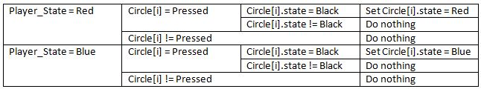

###### Table 4: mousePressed() tabular expression

### 3.2.12 CLASS: BOARDVIEW

Creates the information that the controller will access in order to communicate to the user. The controller will call the view and this is what will draw the graphics to the application window.

***INTERFACE***

***USES***

Screen

Board

Circle[]

***VARIABLES***

**board: Board**

Represent the the Board object from Model.

This variable is kept private to reduce coupling between modules, and implement information hiding. It is maintained by the constructor, setBoardState, getBoardState, millExists, existsOnlyMills, checkWinner, and getRepeats.

**N: int**

Number of squares.

This variable is kept private to reduce coupling between modules, and implement information hiding. It is maintained by the constructor and draw().

**states: int[]**

Array of integers that holds each state.

This variable is kept private to reduce coupling between modules, and implement information hiding. It is maintained by the constructor, pieceNotTaken, getBoardStates, setBoardStates, and drawCircle.

**COLORS = { Color.BLACK, Color.BLUE, Color.RED }: Color[]**

If a third colour was introduced, add it here.

This variable is final.

**RECTANGLE\_WIDTH\_SCALING = 0.19: double**

Rectangle width scaling.

This variable is final.

**RECTANGLE\_HEIGHT\_SCALING = 0.19: double**

Rectangle height scaling.

This variable is final.

**CIRCLE\_SCALING = 0.07: double**

Circle scaling.

This variable is final.

**HORIZONTAL\_LINE\_SCALING**

**= (CIRCLE\_SCALING/RECTANGLE\_WIDTH\_SCALING)\*0.9: double**

Horizontal line scaling.

This variable is final.

**VERTICAL\_LINE\_SCALING**

**=(CIRCLE\_SCALING/RECTANGLE\_HEIGHT\_SCALING)\*0.9: double**

Vertical line scaling.

This variable is final.

**circles: Circle[]**

Array of circles , will be used multiple times.

This variable is kept private to reduce coupling between modules, and implement information hiding. It is maintained by the constructor, getCircles, and drawBoardCircles.

***ACCESS PROGRAMS***

**BoardView(int N)**

Construct a board from the board model, where N is the number of pieces (squares).

**BoardView(int N, int[] boardState)**

Construct the board from the model using a current state.

**pieceNotTaken(int number): boolean**

This method will allow us to make sure the user can only place one piece per node on the board. It will return a boolean value that determines if a piece is already places in location FALSE, a piece is already there.

**getBoardStates(): int[]**

Return the state of the board (player Red or player Blue).

**setBoardState(int number, int state): void**

Set the state of the board. Number is the specific index of the array of states. State will be the previous state of the board and will be updated

**getBoardState(int number): int**

Returns the current state of the board from accessing getPieceState. Number is the number used to index the array of states.

**getCircles(): Circle[]**

Return the array of all circles in the board

**setState(int[] states): void**

Set the states of the game. States is the array of states (black, red, blue).

**draw(Graphics g): void**

Draw the entire board.

**drawRectangle(Graphics g, Rectangle rect): void**

Draws a black rectangle (layer / square) that updates based on window size.

**drawCircle(Graphcis g, Circle circle, int state): void**

Draws a coloured circle based on current state of the board.switch states[state]

*case 0:*

*set colour to black*

*case 1:*

*set colour to blue*

*case 2:*

*set colour to red*

*default:*

*set colour to green*

**drawLine(Graphics g, Point a, Point b): void**

Draw a line from point a to b. This will be used to connect layers.

**drawBoardCircles(Graphics g, Rectangle rect, int layer): void**

Draw all circles needed for the board

*Instantiate points → Draws Circles*

**drawMiddleLines(Graphics g, Rectangle rect): void**

Connect the layers of the board together through the midpoints of inner layers.

*diameterWidth = rectangle width \* (0.07/0.19)\*0.9*

*diameterHeight = rectangle height\*(0.07/0.19)0.9*

*Instantiate points → Draw lines*

**drawBoard(Graphics g, int N): void**

Draw the entire board based on predetermined scaling constants.

*Instantiate Points*

*for i in range of length N*

*New Rectangle object*

*if i<(N-1)*

*drawMiddleLines*

*drawRectangle*

*drawBoardCircles*

**updateScreen(): void**

Updates the screen.

**paintComponent(Graphics g): void**

Draw sections of the board only when they need to be.

**millExists(int i): boolean**

Returns whether a mill including the piece at index i exists by querying the Board model.

**existsOnlyMills(int colour): boolean**

Returns whether there only exists mills on the board with the specified colour by querying the Board model.

**checkWinner(): int**

Returns whether or not there is a winner in the game by querying the Board model: 0 if there is no winner, 1 if the winner is blue, 2 if the winner is red.

**getRepeats():int**

Returns the number of repetitions by querying the Board model.

### 3.2.13 CLASS: GAME

Launches the menu.

**INTERFACE**

**TYPE**

None

**VARIABLES**

None

**ACCESS PROGRAMS**

**main(String[] args): void**

Main method that calls the controller constructor. This makes the menu appear. Create a new menuController object and set to visible.

# 4 Trace to Requirements

The table below lists the assignment’s requirements, and the modules that fulfil those requirements.

|  |  |  |
| --- | --- | --- |
| **Requirements** | **Modules** | **How is it achieved** |
| **Assignment 1** | | |
| Enable the user to set up a board to play the game. | Board, BoardController, BoardView | The user initiate the game through clicking the JLable from BoardView, which calls the BoardController to create a new board from Board. |
| The board includes two types of discs. | BoardController, BoardView | BoardController sets up two different player with their own discs. BoardView sets up different colours for the two types of discs. |
| The discs are placed on either side of the board. | BoardController | BoardController has different JLables to display the number of discs on each side. |
| There are no discs at the start of the game. | BoardController, Board, BoardView | BoardController creates a Board object at the start of the game. Board is initialized with an empty array of discs. BoardView displays nodes with no disc as black. |
| The order of play is determined randomly. | BoardController | In the constructor, BoardController generates a random integer from 1 to 2 to determine whose turn it is. |
| The user should be able to start a new game, or enter discs to represent the current state of a game. | MenuController, MenuView | User can interact with JLables on MenuView, which will call MenuController for corresponding actions. |
| The user should be able to enter discs to represent the current state of a game by selecting a colour and clicking on the position of the disc. | DebugController, Board, BoardView | The user mouse click is received by DebugController, which will modify the Board, and update BoardView correspondingly. |
| When all the discs the user wants to play have been played, the system should analyze whether the current state is possible. | DebugController | In DebugController, boardIsLegal will be called to determine whether the current board state is legal. |
| Errors should be displayed to the user. | ErrorDialog | ErrorDialog extends JDialog, and the constructor will take a JFrame to be displayed in, a string for title, and string for message. Then it will be displayed onto the JFrame by this.setVisible(true). |
| **Assignment 2** | | |
| Enable user to place pieces in turns | BoardController, BoardView, Board | In BoardController, placePieceState is used to determine which player’s turn it is. And mousePressed will allow the corresponding user to place a disc. |
| All move has to be legal moves | DebugController, BoardController, BoardView, Board | Upon a mouse click event, the view and model will only be updated when boardIsLegal return true. |
| Determine which player won | Board, BoardView, BoardController | In Board.checkWinner, it will count the number of discs from each player, and return the player who has more than 2 discs. |
| Result of the game is displayed at all times | BoardController | In BoardController, a JLable is used to display state, and another variable, state, is used to represent the current state. |
| Order of the play is determined randomly. | BoardController | In the constructor, BoardController generates a random integer from 1 to 2 to determine whose turn it is. |
| User is able to choose to start a new game, store an existing unfinished game, and restart a stored game. | MenuView, BoardController | In MenuView, different JButton is created for new game, and continue from an existing one. Then the BoardController will be called upon mouse click of the above JButtons. Save game is handled by BoardController. Upon mouse click of the JButton for save game, BoardController will create “saveGame.txt” to store the board state. |

###### Table 5: Traceability

# 5 Uses Relationship

The figure below shows the dependencies between the different modules. Arrows point from the user to the dependency.

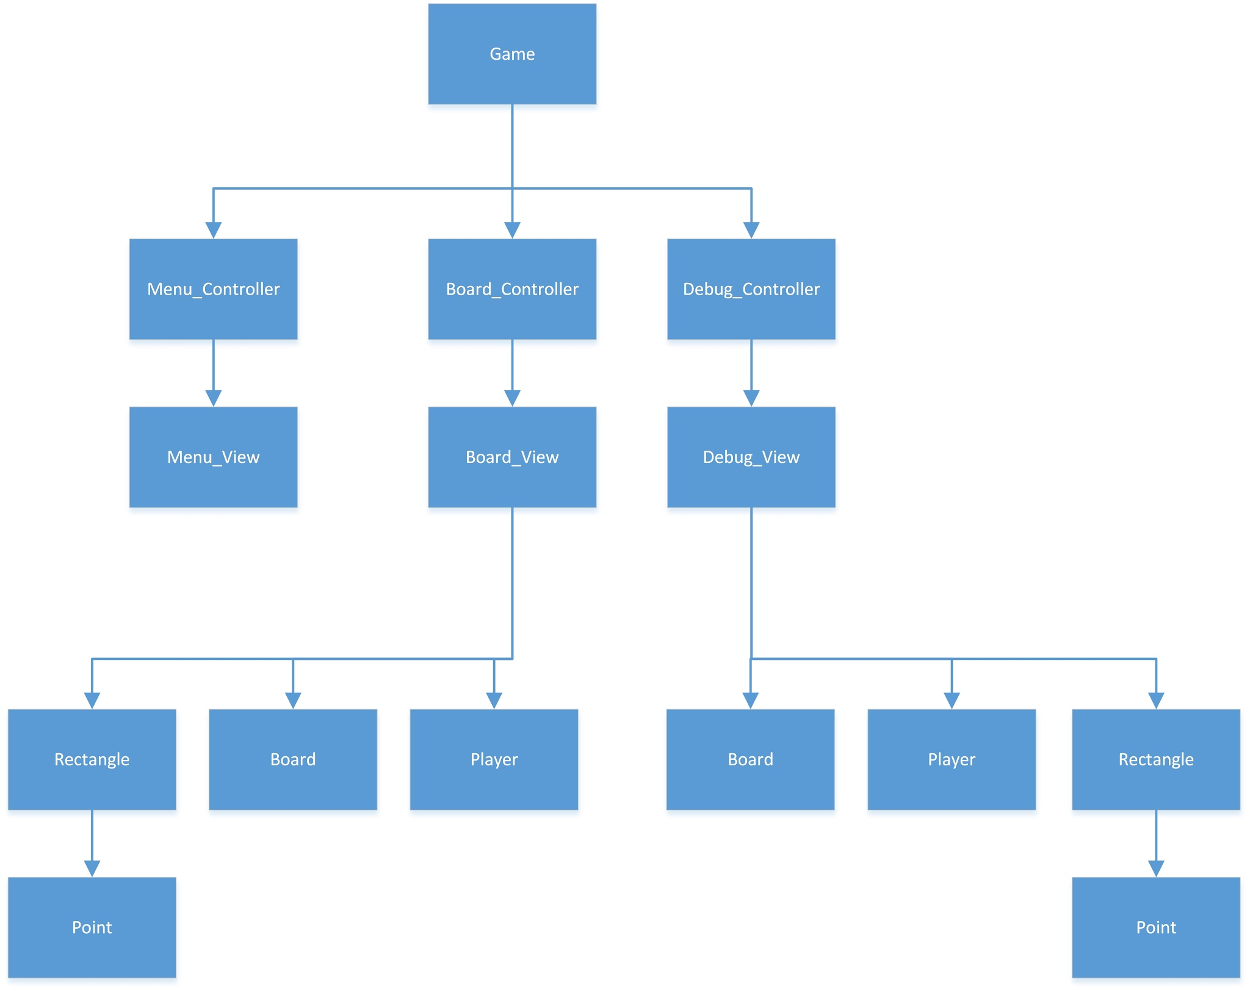

##### Figure 2: The Decomposition Hierarchy

From the diagram above, it is clear that the gameuses three different controllers: the menu controller, the board controller, and the debug controller. This relationship demonstrates that the game is made up of three different states, and it provides a point of entry to the program for a programmer implementing Six Men’s Morris. The controllers each use a separate view, indicating that the controllers manipulate the view. This is also an important relationship, as it explicitly denotes that the controller controls the view and not vice versa. Finally, each view uses models. This relationship is crucial to the success of the program as it shows that the models reflect the views. This relationship is also crucial as the controller depends on the models to be reflective of the view in its state logic.

# 6 Anticipated Changes & Discussion

In the design of Assignment 1, we anticipated the following changes:

* The BoardController can move between different states (i.e. setup, play, results)
* The player can play against the computer
* The application must efficiently store and search for a piece’s next path
* There game can be expanded to N Men’s Morris, where N is greater than 6
* Additional components can be added onto the BoardView and the DebugView
* Users can make an infinite number of moves
* The platform which to run the game will change over time
* The resolution of computer screens will change over time

The following subsections will examine each of the items above, and it will discuss how design decisions were made in Assignment 1 in order to accommodate for these changes.

## 6.1 There Can Be More States than the Defined States

The MenuController class allows for additional classes to be added to the application. It serves as a link to other states, so that an unforeseen state, such as the option to play another game besides N-Men’s Morris can be implemented as another module within the same application.

## 6.2 The Player Can Play Against the Computer

In this application, the Player is modelled as an abstract data type. This means that a computer can be programmed to call commands that a human user could make using the mouse. Instead of solely relying on mouse input to place pieces on the board, mouse events trigger methods in the Player object, which in turn places a piece on the board.

## 6.3 The application must efficiently store and search for a piece’s next path

The board in this application is implemented as a 1 dimensional array. This means that every element in the array will contain a value, so that no additional space is required. Also, the board is represented such that the adjacent nodes are beside each other in the array, or eight spots in front or behind. This makes checking the state of the board efficient, as a series of modular functions can be used in order to check the relevant pieces. The use of recursion can be avoided, as the traditional graph representation unused, hence saving both time and space.

## 6.4 The Game Can Be Expanded to N Men’s Morris

The modules are implemented such that the number of layers (of rectangles) the board contains, and the number of pieces each player has is contained in variables such as N and NUMBER\_OF\_PIECES. This makes modification of such parameters simple, as the rest of the code will remain constant.

## 6.5 Additional Components Can Be Added to the Views

Different components of the screen are encapsulated into JPanels which are then assembled in the controller. This allows for new components to be created as JPanels which can then replace existing components in the screen.

## 6.6 The Users Can Make an Infinite Number of Moves

The turn based system is implemented such that one player increments the turn counter while the other player decrements the turn counter. This makes the turn counter switch between 0 and 1. This allows for an infinite number of moves to be played while using as little space as possible. That is, the program will not crash if 2 computers decided to play against each other, and they use more than 232 moves.

## 6.7 The Platform Will Change Over Time

Java was the language of choice because it allowed for cross-platform integration of the application. Additionally, only the standard Java libraries were used in order to allow users to run the application with the minimal number of additional installations. This saves usage space, and it further prevents compatibility and licensing issues. The user of standard Java library is also, in our opinion, the best guarantee that the libraries used will be supported, as long as Java is supported.

## 6.8 The Resolution of Computer Screens Will Change Over Time

The program has been designed to fit screens of all shapes and sizes. The size of the components on the screen is based on the the screen’s width and height, and the user can resize the screen so that it fits comfortable on their monitor. The screen is rendered at a resolution of 500 x 500, which is small for 2016 standards, so that it can accommodate platforms with smaller screens, but it can be scaled indefinitely large for larger screens.

# 7 Test Plan/Design

## 7.1 Testing for Assignment 1

### 7.1.1 Requirement 1

|  |
| --- |
| **Test #:** 1 |
| **Units/Modules/Requirements:** Enable the user to set up a board to play the game |
| **Test Type:** Black Box (Functional Testing) |

|  |  |
| --- | --- |
| **Input** | **Result** |
| Run MenuController and choose Start game. | Window with a board with 2 rectangles, within the other, with circles on the corners and at the midpoint of the lines. Lines connecting the middle circles of the big rectangle to the middle circles of the middle rectangle. |

###### Table 6: Testing Requirement 1.1

Conclusion: This is the proper set-up for 6 Men’s Morris.

### 7.1.2 Requirement 2

|  |
| --- |
| **Test #:** 2 |
| **Units/Modules/Requirements:** The board includes 2 types of discs |
| **Test Type:** Black Box (Functional Testing) |

|  |  |
| --- | --- |
| **Input** | **Result** |
| Run MenuController, choose start game, place discs on black circles. | Discs placed alternate between red and blue, the first colour determined randomly. |

###### Table 7: Testing Requirement 1.2

Conclusion: There are red and blue discs

### 7.1.3 Requirement 3

|  |
| --- |
| **Test #:** 3 |
| **Units/Modules/Requirements:** The discs are placed on either side of the board |
| **Test Type:** Black Box (Functional Testing) |

|  |  |
| --- | --- |
| **Input** | **Result** |
| Run MenuController, choose start game, place discs on black circles. | On the left there is the amount of Blue discs remaining, on the right the amount of Red (beginning with 6 discs each). When a disc is place the number decreases depending on the colour of the disc placed. |

###### Table 8: Testing Requirement 1.3

Conclusion: The amount of discs for each player is placed on the sides of the board. The amount of discs decreases as they are placed.

### 7.1.4 Requirement 4

|  |
| --- |
| **Test #:** 4 |
| **Units/Modules/Requirements:** There are no discs at the start of the game |
| **Test Type:** Black Box (Functional Testing) |

|  |  |
| --- | --- |
| **Input** | **Result** |
| Run MenuController, choose start game. | All the circles on the board are black, not red or blue. |

###### Table 9: Testing Requirement 1.4

Conclusion: Black circles mean there are no discs placed on them. There are no discs at the start of the game.

### 7.1.5 Requirement 5

|  |
| --- |
| **Test #:** 5 |
| **Units/Modules/Requirements:** The order of play is determined randomly |
| **Test Type:** Black Box (Functional Testing) |

|  |  |
| --- | --- |
| **Input** | **Result** |
| Run MenuController, choose Start Game and place a piece anywhere. | Blue piece placed |
| Run MenuController, choose Start Game and place a piece anywhere. | Red piece placed |
| Run MenuController, choose Start Game and place a piece anywhere. | Blue piece placed |
| Run MenuController, choose Start Game and place a piece anywhere. | Blue piece placed |

###### Table 10: Testing Requirement 1.5

Conclusion: The starting colour is not consistent; therefore, the starting colour is randomly decided every time.

### 7.1.6 Requirement 6

|  |
| --- |
| **Test #:** 6 |
| **Units/Modules/Requirements:** The user should be able to start a new game, or enter discs to represent the current state of the game |
| **Test Type:** Black Box (Functional Testing) |

|  |  |
| --- | --- |
| **Input** | **Result** |
| Run MenuController, click Start Game. | Menu with option of Start game or Debug. When Start game button clicked goes to game mode. |
| Run MenuController, click Debug. | Menu with option of Start game or Debug. When Debug chosen it gives the user the option of what colour to place and user is able to place pieces. |

###### Table 11: Testing Requirement 1.6

Conclusion: Menu directs the user to either game mode or to place pieces and then start the game.

### 7.1.7 Requirement 7

|  |
| --- |
| **Test #:** 7 |
| **Units/Modules/Requirements:** The user should be able to enter discs to represent the current state of a game by selecting a colour and clicking on the position of the disc |
| **Test Type:** Black Box (Functional Testing) |

|  |  |
| --- | --- |
| **Input** | **Result** |
| Run MenuController and choose Debug, choose colours and click circles. | Circles clicked change to the colour of the colour chosen from the menu on the left. |

###### Table 12: Testing Requirement 1.7

Conclusion: The circles clicked change to the colour chosen and the user is able to enter the discs to represent a state of the game.

### 7.1.8 Requirement 8

|  |
| --- |
| **Test #:** 8 |
| **Units/Modules/Requirements:** When all discs the user wants to play have been played, the system should analyse whether the current state is possible |
| **Test Type:** Black Box (Functional Testing) |

|  |  |
| --- | --- |
| **Input** | **Result** |
| Run MenuController, choose Debug, place 4 blue pieces and 4 red pieces. Play game. | Game mode begins. |
| Run MenuController, choose Debug, place 1 blue pieces and 3 red pieces. Play game. | The user receives an error message. |
| Run MenuController, choose Debug, place 3 blue pieces and 1 red pieces. Play game. | The user receives an error message. |
| Run MenuController, choose Debug, place 10 blue pieces and 3 red pieces. Play game. | The user receives an error message. |
| Run MenuController, choose Debug, place 3 blue pieces and 10 red pieces. Play game. | The user receives an error message. |

###### Table 13: Testing Requirement 1.8

Conclusion: When a legal amount of discs are placed, the player is able to play the game. When an illegal amount of discs is placed, the user receives an error message.

### 7.1.9 Requirement 9

|  |
| --- |
| **Test #:** 9 |
| **Units/Modules/Requirements:** Errors should be displayed to the user |
| **Test Type:** Black Box (Functional Testing) |

|  |  |
| --- | --- |
| **Input** | **Result** |
| Run MenuController, choose Debug, place 10 blue pieces and 6 red pieces. Play game. | Error window appears, there are too many pieces. |
| Press OK on error message, replace all pieces with black. Play game | Error window appears, both players have fewer than 3 pieces. |

###### Table 14: Testing Requirement 1.9

Conclusion: When a user tries to make an impossible state the application tells them that it is illegal and why. The user is able to go back and change the discs to create a legal state.

## 

## 7.2 Testing for Assignment 2

### 7.2.1 Requirement 1

|  |
| --- |
| **Test #:** 1 |
| **Units/Modules/Requirements:** The player is able to make moves in turns |
| **Test Type:** Black Box (Functional Testing) |

|  |  |  |  |
| --- | --- | --- | --- |
| **Case (Input)** | **Expected** | **Actual** | **Pass/Fail** |
| Play a blue piece, and then a red piece | Blue piece played.  Red piece played. | Blue piece played.  Red piece played. | Pass |
| Play a red piece and then a blue piece | Red piece played.  Blue piece played. | Red piece played.  Blue piece played. | Pass |
| Play a blue piece to form a mill, remove a red piece, and then play a red piece | Blue piece played.  Mill formed, red piece removed.  Red piece played. | Blue piece played.  Mill formed, red piece removed.  Red piece played. | Pass |
| Play a red piece to form a mill, remove a blue piece, and then play a blue piece | Red piece played.  Mill formed, blue piece removed.  Blue piece played. | Red piece played.  Mill formed, blue piece removed.  Blue piece played. | Pass |
| Place a blue piece on the board. Then, place a red piece on the board. | Blue piece placed on board.  Red piece placed on board. | Blue piece placed on board.  Red piece placed on board. | Pass |
| Place a red piece on the board. Then place a blue piece on the board. | Red piece played on board.  Blue piece played on board. | Red piece played on board.  Blue piece played on board. | Pass |

###### Table 15: Testing Requirement 2.1

### 7.2.2 Requirement 2

|  |
| --- |
| **Test #:** 2 |
| **Units/Modules/Requirements:** The moves have to be legal moves |
| **Test Type:** Black Box (Functional Testing) |

|  |  |  |  |
| --- | --- | --- | --- |
| **Case (Input)** | **Expected** | **Actual** | **Pass/Fail** |
| Move top left most piece up (assume adjacent spots are empty). | ErrorDialog | ErrorDialog | Pass (This counts as a pass because the program behaved as expected). |
| Move top left most piece down (assume adjacent spots are empty). | Piece moves down | Piece moves down | Pass |
| Move top left most piece left (assume adjacent spots are empty). | ErrorDialog | ErrorDialog | Pass |
| Move top left most piece right (assume adjacent spots are empty). | Piece moves right | Piece moves right | Pass |
| Move bottom center piece up (assume adjacent spots are empty). | Piece moves up | Piece moves up | Pass |
| Move bottom center piece down (assume adjacent spots are empty). | ErrorDialog | Error dialog | Pass |
| Move bottom center piece left (assume adjacent spots are empty). | Piece moves left | Piece moves left | Pass |
| Move bottom center piece right (assume adjacent spots are empty). | Piece moves right | Piece moves right | Pass |
| Move piece in top center of inner layer up to an already filled spot. | ErrorDialog | ErrorDialog | Pass |
| Move piece in center right of inner to a non-adjacent empty square. | ErrorDialog | ErrorDialog | Pass |
| Move square in center right of outer layer to a non-adjacent filled square. | ErrorDialog | ErrorDialog | Pass |

###### Table 16: Testing Requirement 2.2

### 7.2.3 Requirement 3

|  |
| --- |
| **Test #:** 3 |
| **Units/Modules/Requirements:** The application has to recognize when the game has been won. |
| **Test Type:** Black Box (Functional Testing) |

|  |  |  |  |
| --- | --- | --- | --- |
| **Case (Input)** | **Expected** | **Actual** | **Pass/Fail** |
| Win game with red player. | Game transitions to “Red Won” | Game transitions to “Red Won” | Pass |
| Win game with blue player. | Game transitions to “Blue Won” | Game transitions to “Blue Won” | Pass |

###### Table 17: Testing Requirement 2.3

### 7.2.4 Requirement 4

|  |
| --- |
| **Test #:** 4 |
| **Units/Modules/Requirements:** The game has to recognize when the game cannot be won. |
| **Test Type:** Black Box (Functional Testing) |

|  |  |  |  |
| --- | --- | --- | --- |
| **Case (Input)** | **Expected** | **Actual** | **Pass/Fail** |
| Draw game on a red move. | Game transitions to “Game Drawn” | Game transitions to “Game Drawn” | Pass |
| Draw game on a blue move. | Game transitions to “Game Drawn” | Game transitions to “Game Drawn” | Pass |
| Trap blue so that blue has no legal moves. | Game transitions to “Red Win” | Game transitions to “Red Win” | Pass |
| Trap red so that red has no legal moves. | Game transitions to “Blue Win” | Game transitions to “Blue Win” | Pass |

###### Table 18: Testing Requirement 2.4

### 7.2.4 Requirement 5

|  |
| --- |
| **Test #:** 5 |
| **Units/Modules/Requirements:** The result of the game must be displayed at all times. |
| **Test Type:** Black Box (Functional Testing) |

|  |  |  |  |
| --- | --- | --- | --- |
| **Case (Input)** | **Expected** | **Actual** | **Pass/Fail** |
| Start the game | JLabel displays “Game in Progress” | JLabel displays “Game in Progress” | Pass |
| Enter place pieces stage | JLabel displays “Game in Progress” | JLabel displays “Game in Progress” | Pass |
| Enter play game state | JLabel displays “Game in Progress” | JLabel displays “Game in Progress” | Pass |
| Enter blue won state | JLabel displays “Blue Won” | JLabel displays “Blue Won” | Pass |
| Enter red won state | JLabel displays “Red Won” | JLabel displays “Red Won” | Pass |
| Enter game drawn state | JLabel displays “Game Drawn” | JLabel displays “Game Drawn” | Pass |
| Enter game using the Load Game button, from place piece stage. | JLabel displays “Game in Progress” | JLabel displays “Game in Progress” | Pass |
| Enter game using the Load Game button, from play game stage. | JLabel displays “Game in Progress” | JLabel displays “Game in Progress” | Pass |
| Enter game using the Load Game button, from red won stage. | JLabel displays “Red Won” | JLabel displays “Red Won” | Pass |
| Enter game using the Load Game button, from blue won stage. | JLabel displays “Blue Won” | JLabel displays “Blue Won” | Pass |
| Enter game using the Load Game button, from game drawn stage. | JLabel displays “Game Drawn” | JLabel displays “Game Drawn” | Pass |

###### Table 19: Testing Requirement 2.5

### 7.2.6 Requirement 6

|  |
| --- |
| **Test #:** 6 |
| **Units/Modules/Requirements:** Each move must be checked to show that it is legal. |
| **Test Type:** Black Box (Functional Testing) |

|  |  |  |  |
| --- | --- | --- | --- |
| **Case (Input)** | **Expected** | **Actual** | **Pass/Fail** |
| Move upper center piece on the outer layer to an empty adjacent square on the right. | Piece moves to the right | Piece moves to the right | Pass |
| Move center right piece on outer layer to an adjacent filled square down. | ErrorDialog | ErrorDialog | Pass |
| Move lower center piece on inner layer to a non-adjacent empty square up. | ErrorDialog | ErrorDialog | Pass |
| Move upper center piece in inner layer to a non-adjacent filled square left. | ErrorDialog | ErrorDialog | Pass |
| Red tries to move a blue piece. | ErrorDialog | ErrorDialog | Pass |
| Blue tries to move a red piece. | ErrorDialog | ErrorDialog | Pass |
| Red captures a blue piece not part of a mill. | Blue piece captured | Blue piece captured | Pass |
| Blue captures a red piece not part of a mill. | Red piece captured | Red piece captured | Pass |
| Red captures a blue piece that is part of a mill, when a blue piece that is not part of a mill exists. | ErrorDialog | ErrorDialog | Pass |
| Blue captures a red piece that is part of a mill when a red piece that is not part of a mill exists. | ErrorDialog | ErrorDialog | Pass |
| Red captures a blue piece that is part of a mill when only blue mills exist. | Blue piece captured | Blue piece captured | Pass |
| Blue captures a red piece that is part of a mill when only red mills exist. | Red piece captured | Red piece captured | Pass |
| Red tries to capture a red piece. | ErrorDialog | ErrorDialog | Pass |
| Blue tries to capture a blue piece. | ErrorDialog | ErrorDialog | Pass |

###### Table 20: Testing Requirement 2.6

### 7.2.7 Requirement 7

|  |
| --- |
| **Test #:** 7 |
| **Units/Modules/Requirements:** The order of play (blue first or red first) shall be determined randomly |
| **Test Type:** Black Box (Functional Testing) |

|  |  |  |  |
| --- | --- | --- | --- |
| **Case (Input)** | **Expected** | **Actual** | **Pass/Fail** |
| Start game until blue goes first | After n repetitions, blue goes first | After starting the game once, blue went first | Pass |
| Start game until red goes first. | After n repetitions, red goes first | After restarting the game 4 times, red went first. | Pass |

###### Table 21: Testing Requirement 2.7

### 7.2.8 Requirement 8

|  |
| --- |
| **Test #:** 8 |
| **Units/Modules/Requirements:** The user shall be able to start a new game, store an existing unfinished game, and restart a stored game |
| **Test Type:** Black Box (Functional Testing) |

|  |  |  |  |
| --- | --- | --- | --- |
| **Case (Input)** | **Expected** | **Actual** | **Pass/Fail** |
| Start a new game | Game starts | Game starts | Pass |
| Save a game in the place pieces state, on red’s turn | Game saved | Game saved | Pass |
| Save a game in the place pieces state, on blue’s turn | Game saved | Game saved | Pass |
| Load a game in the place pieces state, on red’s turn | Game loads on red’s turn with appropriate number of pieces | Game loads on red’s turn with appropriate number of pieces | Pass |
| Load a game in the place pieces state, on blue’s turn | Game loads on blue’s turn with appropriate number of pieces | Game loads on red’s turn with appropriate number of pieces | Pass |
| Save a game in the play state, on red’s turn during a movement | Game saved | Game saved | Pass |
| Save a game in the play state, on blue’s turn, during a movement | Game saved | Game saved | Pass |
| Save a game in the play state, on red’s turn during which red may capture a blue piece. | Game saved | Game saved | Pass |
| Save a game in the play state, on blue’s turn, during which blue may capture a red piece | Game saved | Game saved | Pass |
| Load a game in the play state, on red’s turn during a movement | Game loaded on red’s turn, and allowed red to move | Game loaded on red’s turn, and allowed red to move | Pass |
| Load a game in the play state, on blue’s turn during a movement | Game loaded on blue’s turn, and allowed blue to move | Game loaded on blue’s turn, and allowed blue to move | Pass |
| Load a game in the play state, on red’s turn, during which red can capture a blue piece. | Game loaded on red’s turn, and allowed red to mill. | Game loaded on red’s turn, and allowed red to mill. | Pass |
| Load a game in the play state, on blue’s turn, during which blue may capture a red piece. | Game loaded on blue’s turn, and allowed blue to mill. | Game loaded on blue’s turn, and allowed blue to mill. | Pass |
| Save a game on red win | Game saved | Game saved | Pass |
| Save a game on blue win | Game saved | Game saved | Pass |
| Save a game on game drawn | Game saved | Game saved | Pass |
| Load a game on red win | Game loaded on red win state | Game loaded on red win state | Pass |
| Load a game on blue win | Game loaded on blue win state | Game loaded on blue win state | Pass |
| Load a game on game drawn | Game loaded on game drawn state | Game loaded on game drawn state | Pass |

###### Table 22: Testing Requirement 2.8

# 8 Conclusion

This report details the design decisions made and the implementation of assignment 2. Overall, we believe that this is a robust implementation of Six Men’s Morris that exemplifies the principles of software engineering. The requirements of this application were first formally defined, and attempts at using tabular expressions and mathematical functions to model the problem were made. This lead to the inception of a board-checking algorithm which allows for the board to have a space complexity proportional to the number of pieces on the board while maintaining linear search time in the worst case. Furthermore, three separate controllers and views were developed from formally defining the requirements, which allowed each state of the application to remain independent of the other states. This allows our program to exhibit separation of concerns. Through the decomposition of our program, we were able to separate our program into three main areas, models, controllers, and views. This ultimately allowed us to create a program using the MVC architecture. The components of the MVC model in the implementation allowed for modularity and abstraction. ADTs were created which allowed for information hiding, low coupling between different states, and high cohesion. The creation of modules also allowed us to anticipate change. We were able to implement the assignment such that it could be easily modified to accommodate future changes. Both separation of concerns and modularity in our code allowed us to implement changes with minimal change to the overall interface of the code.

In comparison with the old implementation, submitted by Zichen, Danish, and Hasan, several notable changes were made. In the current implementation of Six Men’s Morris, the three initial modules, Model, Controller, and View were further decomposed into individual modules. This promoted separation of concerns because the overall game can now function despite the further compartmentalization. It is also easy to implement future changes as modules are now loosely coupled and changing one will seldom affect the behaviour of another module. Furthermore, the new implementation of Six Men’s Morris is more space and time efficient than the previous iteration, making it more deployable on a wider range of platforms.

Despite these advantages, however, disadvantages still arise from using the current implementation of Six Men’s Morris over the previous version of Six Men’s Morris. The previous version of Six Men’s Morris has a more intuitive user interface, indicating to the user which piece the user has selected. It also exhibits better placement of the components. Nevertheless, despite the advantages of the previous implementation, the current implementation was chosen for its robust design and its exposition of the software engineering principles that allowed us to easily implement assignment 3.

Therefore, since our implementation of assignment 2 embodies all of the principles of software engineering, we believe that our application is a robust implementation of the Six Men’s Morris interactive game.

# 9 Appendix

## 9.1 Change log

* Added new methods, millExists and onlyMillsLeft, into Class: Board (3.1.10) under MIS and Class: Board (3.2.10) under MID
* Remove MIS for Class: View (originally 3.1.10), as the class no longer exists
* Added new variables, piecesHistory, counter, and repeats, into Class: Board (3.2.10) under MID
* Added new methods, boardIsEqual, into Class: Board (3.1.10) under MIS and Class: Board (3.2.10) under MID
* New methods added to Class: BoardController (3.2.11) under MID and Class: BoardController (3.1.11) under MIS.
* Added test plan for requirements in assignment 2
* Modified the format of assignment test plan to match the new test plan
* Added private implementation for all classes
* Added more explanation for module decomposition
* Added new content for internal review
* Added new variables and methods into Class: MenuView under MIS (3.1.5) and MID (3.2.5)
* Added noPossibleMoves() to BoardController.java and BoardController MID.

## 9.2 List of Tables

Table 1: checkNumbers() tabular expression 15

Table 2: getNextState() tabular expression 17

Table 3: millExists() tabular expression 24

Table 4: mousePressed() tabular expression 29

Table 5: Traceability 34

Table 6: Testing Requirement 1.1 38

Table 7: Testing Requirement 1.2 38

Table 8: Testing Requirement 1.3 39

Table 9: Testing Requirement 1.4 39

Table 10: Testing Requirement 1.5 40

Table 11: Testing Requirement 1.6 40

Table 12: Testing Requirement 1.7 41

Table 13: Testing Requirement 1.8 41

Table 14: Testing Requirement 1.9 42

Table 15: Testing Requirement 2.1 43

Table 16: Testing Requirement 2.2 44

Table 17: Testing Requirement 2.3 44

Table 18: Testing Requirement 2.4 45

Table 19: Testing Requirement 2.5 46

Table 20: Testing Requirement 2.6 48

Table 21: Testing Requirement 2.7 48

Table 22: Testing Requirement 2.8 50

## 

## 9.3 List of Figures

Figure 1: The Decomposition Hierarchy 4

Figure 2: The Decomposition Hierarchy 35